Statistical analysis of the impact of integrating students with special educational needs on their regular peers within the educational environment

Sawsan Kara¹ , Nadia Ghalia², Mawaheb kheir Mustafa³ , HIYAM ABU REYA⁴ and Darawsheh Ahlam⁵

¹ An educator Ministry of Education, Dalyat El Karmel, Israel, karasawsan8@gmail.com
² The Academic Arab College for Education in Haifa, Nadiahgalie@arabcol.ac.il
³ An educator Ministry of Education, Dalyat El Karmel, Israel, Mawaheb25@hotmail.com
⁴ An educator Ministry of Education, Sakhnin, Israel, hiamm72@gmail.com
⁵ Department of Education and Arabic Language Lecturer, Kay College, Beer Sheva, Israel, Sharemoon68@gmail.com

Abstract
Despite global efforts to implement the inclusive education strategies, children with special educational needs still encounter challenging such as years of education, regular school attendance, and academic achievement. This raises concerns about the impact of integrating these children into regular schools on the academic, social and emotional aspects of children without special educational needs since these children are also involved in the inclusive education system.Therefore, this study examined the impact of inclusion on the social, academic and emotional aspects of students without special educational needs. For data collection, a survey analytical descriptive design was employed. The results showed that the inclusion of students with SEN had a significant high level of impact of inclusion on social, academic and emotional. Furthermore, there were no statistically significant gender differences in the impact of inclusion on the social, academic and emotional aspects of students without special educational needs. Based on the results, some recommendations were suggested.
Key words: Inclusion, ,Students Without Special Educational Needs, Social Aspect, Academic Aspect, Emotional Aspect.
Introduction
Inclusive education has become an integral part of teaching methods, providing every student, with or without disabilities, with equal educational opportunities in public schools.Inclusive classrooms help such students to get regular curriculatogether with their peers,making the student with a disability feel that they belong with them, and this enhances their motivation and self-efficacy (Liu &Potmesil, 2025).
In the same vein, inclusive education is also useful to the students without special educational needs since they develop compassion; decrease their negative attitudes towards students with disabilities; and develop communication and collaboration skills.Through their interaction, they gain respect for one another and adopt positive social attitudes, which in turn leads to harmony in the classroom and overall success (Bashir et al., 2026).
Inclusive education holds significant role for students with disabilities. It reshapes the educational process by ensuring that individuals with disabilities are not marginalized but are provided with opportunities to learn alongside their peers.This promote educational outcomes for these students and fosters empathy, understanding, and cooperation among all students (Okoye&Maryqueen, 2025).
According to Leblebici and Türkan(2021), inclusive education is an approach that focuses on transforming the education system to accommodate student diversity. This, in turn, enables teachers and students to feel comfortable with diversity and consider it as a development in the educational process, not a problem. Inclusive education focuses on treating students with disabilities and students without special educational needsequally, by providing them with equal opportunities. In addition, the curriculum in inclusive education isdesigned to be accessible, allowing each student to access learning materials according to their individual abilities and needs.Furthermore, inclusive education involves an important collaboration between teachers, parents, and the community to create a supportive educational environment (Yusuf&Fajari, 2025).
Inclusive education refers to educating students with disabilities in general education classrooms alongside their peers without disabilities. Researchers emphasize that stakeholders’ attitudes, especially teachers’ perceptions-play a central role in determining the success or failure of inclusive education practices. Positive attitudes contribute to effective implementation and improved participation, whereas negative perceptions create barriers to inclusion (Supriyanto, 2019).
Supriyanto (2019) affirmed that teachers’ attitudes toward inclusive education are generally moderate to positive, although variability exists across contexts and educational systems. A literature review analyzing multiple studies found that most teachers support inclusive education but also express concerns related to preparations and classroom challenges.
Moreover, there are several factors influencing attitudes towards inclusion such asteacher training and professional preparationmeans thatprofessional development and training are consistently identified as strong predictors of positive attitudes (Aldosari, 2022); teaching experience and contact with disabilitiesindicate that previous interaction with individuals that have disabilities contributes to more supportive attitudes (Junaidi, 2019); institutional support and classroom environmentmeans that school-level factors such as administrative support, class size, availability of support staff, and access to resources significantly influence educators’ attitudes; institutional support and classroom environment. This means that School-level factors such as administrative support, class size, availability of support staff, and access to resources significantly influence educators’ attitudes (Wahsheh, 2024); Demographic and professional variables. This indicates that Studies have identified differences based on age, gender, teaching specialization, and educational level (Junaidi, 2019); type of disabilities. This shows that attitudes also vary depending on the nature and severity of the disability (García&Resino, 2022).
However, there are several barriers influence negative or neutral attitudes toward the inclusion of students with disabilities including lack of adequate training and professional preparation; large classroom sizes and limited resources; concerns about academic performance and classroom management; insufficientadministrative and institutional support. These challenges often lead educators to feel unprepared or overwhelmed, which may reduce their willingness to implement inclusive strategies effectively (Aldosari, 2022).
Almalky and Alwahbi (2023) confirmed that the implementations of inclusion focus on the disability type rather than the individual needs. Students with learning, physical, and behavioral disabilities are educated in mainstream classrooms, engaging in the standard curriculum with assistance from special education teachers. Special education services can help personalize education by providing practical alternatives to teaching materials, methods, assessments, and learning environments.
As for the different effects of inclusion on students without special educational needs various aspects, there is still paucity in special education literature focusing on the outcomes of inclusion as on special education practice on students without special educational needs and this highlights the importance of examining such an important domain of inclusion. For example, OkoyeandMaryqueen(2025) pointed out that inclusive education promotes social aspects by ensuring that students with disabilities receive the support they need to succeed. Inclusive education enhances educational outcomes, and It builds a more just and equitable society where all individuals, regardless of their abilities, have the opportunity to participate fully in economic, social and civic life.
Inclusive education fosters social collaboration among peers, teachers, and administrators. Resources such as training, expert support, and classroom support contribute to positive teacher attitudes toward inclusive education. For example, peer support has been shown to be a significant factor in establishing positive teacher attitudes toward inclusive education policies (Desombre et al., 2021). In addition, Teachers have an important role in promoting social skills development among all students, including those with disabilities. Inclusive education policiesrecognizethe interconnectedness between academic achievement and social-emotional well-being, highlighting the importance of addressing the holistic needs of students in order to support their overall development and success. This involves providing opportunities for meaningful interactions, offering guidance on social norms and expectations, and supporting students in facing social challenges. They also embody inclusive behaviors and attitudes, which are essential for creating a positive and supportive classroom environment (Obah, 2024).
Moreover, certain students with special needs may face instances of students without special educational needs rejection.This may have negative effects on their social behavior and self-perception.This may lead to decreased self-confidence and possibly limit their social development, making it difficult for them to build strong relationships with students without special educational needs (Chen et al., 2022).
Socio-emotional aspects such as peer acceptance, self-esteem, and social inclusion have been regarded as significant sources of academic performance of students in inclusion classrooms. Inclusive education can provide students with a sense of inclusion and support, which can lead to an increase in motivation, participation, and eventual success (Avramidis & Norwich, 2019).
According to Huang et al. (2025), inclusive educationmay contribute to improvingsocial and emotional skills of students without special educational needs. By interacting with students with disabilities, students without special educational needs can better understand and accept personal differences, thereby reducing prejudice and fostering camaraderie with their peers. As a result, their interpersonal skills, friendships, and acceptance of their peers can gradually develop through daily interaction.
In the same line, student interactions with their peers provide crucial opportunities for both students with disabilities and students without special educational needs to enhance their social and cognitive development. These interactions help students with disabilities feel less isolated in their communities, positively impacting their mental health and fostering a greater sense of social inclusion (Nam &Tan, 2024).
As highlighted by Szumski et al. (2022), inclusive education can enhance the learning outcomes of all students by employing effective strategies such as having a second teacher in inclusive classrooms, providing individualized elements of instruction, such as giving frequent and relevant feedback to students, adapting materials and teaching methods to each student's individual needs, and using appropriate methods to track progress.However, there three reasons why inclusive education may not increase the educational outcomes, including relations between classroom’ teachers and special education teachers are not based on collaboration, with special teachers treated as an assistant instead of instructional partners; special education teachers often lack the necessary subject knowledge to be able to teach alongside classroom teachers; classroom teachers and special education teachers lack sufficient time to plan lessons together.
The positive impact of teaching studentswithout special educational disabilities in inclusive classrooms may be decreased by inappropriate behaviors exhibited by students with disabilities. Students with disabilities, especially those with emotional and behavioral disorders may exhibit disruptive behaviors that upset their peers. Special education teachers ininclusive classrooms are often responsible for taking actions with those students, such as asking them to be quiet or leavingthe classroom with the student to talk to them (Buchner &Proyer, 2020).
Previous Studies
This section of the study presents previous studies examining the effect of inclusion on studentswithout special educational disabilities in inclusive classrooms different psychological and behavioral variables. In one study, Kart and Kart (2021) examined academic and social effects of inclusion on students without disabilities. The researchers employed a qualitative descriptive method by reviewing (26) previous studies. The results showed that inclusive education has positive or neutral effects of inclusion on the academic achievement of students without disabilities in the lower grades, whereas neutral or negative influence is indicated for later grades.
Using a sample of (1552) students without disabilities, selectedfrom three educational settings: general, without students with disabilities, inclusive (with co-teaching),Szumski et al. (2022) conducted a study to examine the academic achievement of students without special educational needs and disabilities in inclusive education. To achieve the objectives of the study, the latent growth curve model was adopted. The results showed that changes in academic achievement over time were similar in all three educational settings; therefore, there were no differences between inclusive education (of the two types) and general education classrooms.
In addition, Pirker et al. (2023) investigated the self-perception of social, emotional, and academic inclusion of students with and without special educational needs. The sample of the study consisted of (6) students with special educational needs and (3) students without special educational needs. The study employed qualitative approach by semi-structure interviews. The results showed that the inclusion of students with special educational needs has positive impact on the social and emotional perceptions of students without special educational needs. As for, the academic aspect of inclusion on students without educational needs, it was found that inclusion did not have a significant impact on students without special educational needs’ academic skills.
Garcíaand Rentería (2024) examined the impact of inclusive education on the educational outcomes of students without Special Educational Needs in Peru. The study sample included (55637) students participating in reading achievement test and (55614) students participating in mathematics achievement test in the age group (6-8 years). Furthermore, the study sample contained (47491) students participating in mathematics achievement test and (47480) students participating in mathematics achievement test in the age group (13-14 years). The results showed that SEN students do not have a significant impact on the academic achievement of students without special educational needs in both reading and mathematics test.
Furthermore, Nam and Tan (2024) investigated the impact of inclusive education on social integration and academic achievement among students with learning disabilities and students without special educational needs in Southern Vietnam. The study sample consisted of (132) students with learning disabilities and (355)students without special educational needs. To achieve the objectives of the study, a mixed-methods research design was employed. The findings showed that inclusive practices significantly enhance social integration, empathy, and understanding among students. For students with learning disabilities, inclusive education has positive impact on academic outcomes, particularly in the early education stages, while students without special educational needs have neutral effects on academic achievements. Additionally, the findings showed that inclusive education has positive impact on social interaction and faster integration into communication networks among students with learning disabilities and students without special educational needs.
Huang et al. (2025) examined the role of inclusive education in academic and social–emotional development of students without special educational needs. The study sample consisted of (1155) Chinese students without special educational needs, were selected from the Survey on Social and `Emotional Skills database from the OECD. To achieve the objectives of the study, the study employed variable- and person- oriented approaches.The results foundthat inclusive education showed no significant effect on academic achievement, and had slight positive correlations with optimism, tolerance and sociability. The study also found that inclusion had a stronger inclusion effect on optimism in less optimistic students (last 25%–50%).
Problem of the study
The problem of this study stems from the fact that the impact of students with SEN inclusion in the public schools on the different aspects of students without SEN has been one of special education topics that did not attracted special education teachers attention despite its important on this group of student and their families. Previous literature has mainly focus on the advantages and disadvantages related to inclusion as a special education practice on students with SEN while their peers without SEN did not have the research focus and this what was evident when reviewing previous studies. As the researchers are special education educators working in inclusive environment, they noticed that students without SEN gain many experiences while interacting with students with SEN and this means that they are affected at the academic, social and emotional levels; an issue needing more examination, especially among Arab students as the researchers did not find any study that investigated how inclusion of students with SEN affect their counterparts of students without SEN and this the main focus of this study.
Questions of the Study
- What is the impact of inclusion on the social, academic and emotional aspects of students without special educational needs?
- Are there statistically significant differences due to gender in the impact of inclusion on the social, academic and emotional aspects of students without special educational needs?

Significance of the Study
The significance of this study arises from its attempts to shed light on the impact of including students with SEN in inclusive schools and to how students without SEN are affected. This opens new ventures for interested special education researchers to examine in the future the impact of including students with SEN on the aspects that have not been addressed in the current study. Furthermore, it is hoped that the results of this study can direct future researchers to address other effects of inclusion of students with SEN on other stakeholders such as teachers and principals working in inclusive public schools. Finally, this study provides an instrument covering the social, academic, and emotional aspects that can be influenced by the inclusion of students with SEN.
Objectives of the Study
- To examine the impact of inclusion on the social, academic and emotional aspects of students without special educational needs.
- To identify whether there are statistically significant differences due to gender in the impact of inclusion on the social, academic and emotional aspects of students without special educational needs.
Limitations of the Study
The limitations of this study can be presented in the followings:
- The sample of the study was confined tostudents without special educational needs, in inclusive public schools and this means that the results cannot be generalized to other students groups.
- The study was conducted in Upper Galilee inclusive schools, and this means that the results obtained in this study cannot be generalized to other geographic regions.
- The study was conducted in the first semester of the school year 2025/2026 and this limits the generalization of the results to other periods.
Method

The study employed asurvey analytical descriptive design.This research design is one of the scientific research paradigms aiming to describe the phenomenon under investigation by using a survey tool like a scale, a questionnaire or any other research instrument. It can both save time and cost for researchers and the results obtained can be generalized to a large scale group of the population the sample of the study belongs to.

Study sample

The sample of the study consisted of 365 students without special educational needs enrolled in inclusive public schools at Upper Galilee District.

Validity and Reliability of the Study Variables

To ensure the accuracy and appropriateness of the study instrument, the Social, Academic, and Emotional Aspects were subjected to validity and reliability testing. Construct validity was verified by calculating the correlation coefficients between each statement and its corresponding domain, as well as with the overall scale, using a pilot sample of 30 respondents who were later excluded from the main study. The results showed that all statements had statistically significant and acceptable correlations, ranging from 0.621 to 0.721, while correlations between each domain and the total scale ranged from 0.701 to 0.93, confirming the instrument’s suitability for measuring the impact of inclusion on the social, academic and emotional aspects of students without special educational needs.

Reliability was assessed using both Cronbach’s alpha for internal consistency and the test-retest method. The Social Aspect showed internal consistency of 0.889 and test-retest reliability of 0.861, the Academic Aspect had values of 0.858 and 0.891, and the Emotional Aspect showed 0.871 and 0.871, respectively. The overall reliability of the instrument across the three aspects was 0.914 for internal consistency and 0.911 for test-retest, indicating that the instrument is highly reliable and accurately measures the intended constructs, as shown in the following table; and fig.

Table 1: Reliability of Social, Academic, and Emotional Aspects
Aspect | Internal Consistency (Cronbach’s Alpha) | Test-Retest Reliability
Social Aspect | 0.889 | 0.861
Academic Aspect | 0.858 | 0.891
Emotional Aspect | 0.871 | 0.871
Overall Scale | 0.914 | 0.911
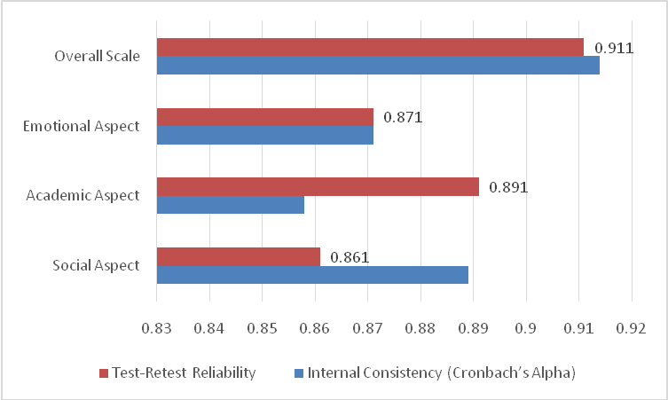

ToolScoring
To interpret the arithmetic means of the study instrument and its items, the five-point Likert scale was employed. The classification of responses was based on the following intervals:
Mean Score Range | Interpretation
1.00 – < 1.80 | Very Low
1.80 – < 2.60 | Low
2.60 – < 3.40 | Moderate
3.40 – < 4.20 | High
4.20 – 5.00 | Very High

Results:

What is the impact of inclusion on the Social, Academic and Emotional Aspects of students without special educational needs?

To answer the first research question, which aimed to examine the impactof inclusion on the social, academic and emotional aspects of students without special educational needs, descriptive statistics were calculated for all study variables. This analysis provides an overview of students’ perceptions regarding the influence of inclusion on their social interactions, academic progress, and emotional development. Additionally, Pearson correlation coefficients were computed to explore the relationships among the main variables, followed by multiple regression analysis to determine the predictive role of social and academic aspects on the emotional aspect. The results are presented in the following tables and figures.

Table 2: Descriptive Statistics of Social, Academic, and Emotional Aspects
Aspect | Mean | Std. Deviation | Level
Social Aspect | 3.662 | 0.541 | High
Academic Aspect | 3.551 | 0.619 | High
Emotional Aspect | 3.663 | 0.549 | High
Table 2 presents the descriptive statistics for the social, academic, and emotional aspects associated with the inclusion of students with special educational needs in regular classrooms. The results indicate that all three dimensions were perceived positively by students without special educational needs, with mean scores ranging from 3.551 to 3.663, reflecting a high level according to the adopted criterion.Among the three dimensions, the Emotional Aspect obtained the highest mean score (M = 3.663, SD = 0.549), followed very closely by the Social Aspect (M = 3.662, SD = 0.541). This finding suggests that inclusion may contribute positively to students’ emotional development by fostering feelings of empathy, acceptance, respect for diversity, and emotional understanding of others. Similarly, the high score of the Social Aspect indicates that inclusion provides opportunities for social interaction, cooperation, communication, and the development of positive relationships among students from diverse backgrounds.The Academic Aspect also received a high rating (M = 3.551, SD = 0.619), although it recorded the lowest mean among the three dimensions. This result may indicate that while students perceive inclusion as beneficial for academic growth, its influence on academic outcomes is somewhat less pronounced than its impact on social and emotional development. Nevertheless, the high mean score reflects a generally positive perception of the academic benefits associated with inclusive educational environments.Furthermore, the relatively low standard deviations across all dimensions (ranging from 0.541 to 0.619) suggest a considerable degree of agreement among participants regarding the positive effects of inclusion. The small differences between the mean scores also indicate that the impact of inclusion is multidimensional, affecting social, academic, and emotional aspects in a balanced manner rather than benefiting only one particular area.
Overall, the findings demonstrate that students without special educational needs perceive inclusion as having a broadly positive influence on their development, particularly in enhancing emotional awareness and social relationships, while also supporting academic progress. These results highlight the value of inclusive education in promoting holistic student development and creating supportive learning environments for all learners., as shown in the following tables and as seen in the figure:
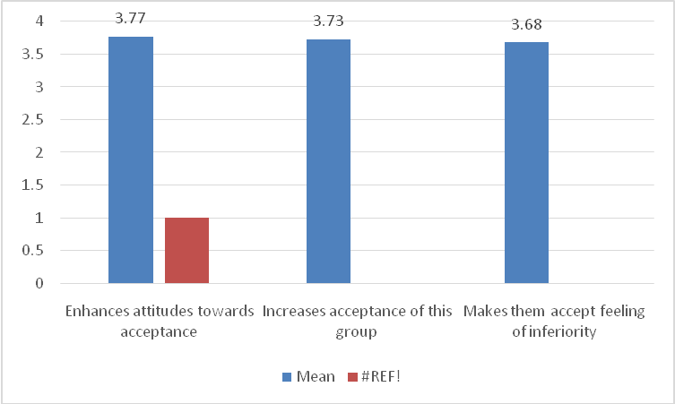

Table 3: Descriptive Statistics of Social Aspect Items
No | Statement | Mean | Std. Deviation | Rank | Level
4 | Improves communication skills | 3.80 | 0.648 | 1 | High
1 | Improves interaction with students without special educational needs | 3.75 | 0.638 | 2 | High
2 | Improves life skills among students without special educational needs | 3.66 | 0.695 | 3 | High
5 | Gives opportunities to make friends | 3.64 | 0.726 | 4 | High
3 | Enhances positive social values | 3.59 | 0.688 | 5 | High
6 | Facilitates ability to share experiences | 3.53 | 0.739 | 6 | High
 | Social Aspect | 3.662 | 0.541 |  | High

The results in the previous table showed that among the social aspect items, "Improves communication skills" ranked first with a mean (3.80) and a standard deviation (0.648), followed by "Improves interaction with students without special educational needs" with a mean (3.75) and a standard deviation (0.638). "Improves life skills among students without special educational needs" came third with a mean (3.66) and a standard deviation (0.695), "Gives opportunities to make friends" ranked fourth with a mean (3.64) and a standard deviation (0.726), "Enhances positive social values" was fifth with a mean (3.59) and a standard deviation (0.688), and "Facilitates ability to share experiences" ranked sixth with a mean (3.53) and a standard deviation (0.739). Overall, the Social Aspect had a mean (3.662) with a standard deviation (0.541) and was at a high level as shown in the following figure:

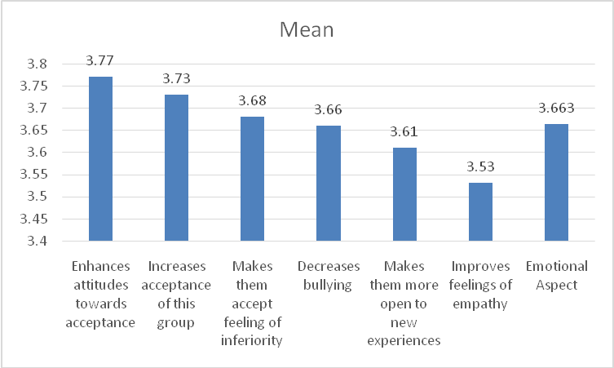
Table 4:Descriptive Statistics of Academic Aspect Items
No | Statement | Mean | Std. Deviation | Rank | Level
5 | Improves quality of learning experiences | 3.66 | 0.744 | 1 | High
4 | Improves self-trust | 3.61 | 0.706 | 2 | High
6 | Improves ability to adapt to different learning environments | 3.61 | 0.782 | 3 | High
3 | Provides new opportunities of learning | 3.58 | 0.772 | 4 | High
1 | Positive effects on academic progress | 3.50 | 0.847 | 5 | High
2 | Provides new challenges | 3.35 | 0.912 | 6 | High
 | Academic Aspect | 3.551 | 0.619 |  | High

The results in the previous table showed that among the academic aspect items, "Improves quality of learning experiences" ranked first with a mean (3.66) and a standard deviation (0.744), followed by "Improves self-trust" with a mean (3.61) and a standard deviation (0.706), and "Improves ability to adapt to different learning environments" also with a mean (3.61) but a standard deviation (0.782), ranking third. "Provides new opportunities of learning" came fourth with a mean (3.58) and a standard deviation (0.772), "Positive effects on academic progress" ranked fifth with a mean (3.50) and a standard deviation (0.847), and "Provides new challenges" was sixth with a mean (3.35) and a standard deviation (0.912). Overall, the Academic Aspect had a mean (3.551) with a standard deviation (0.619) and was at a high level. as shown in the following figure:

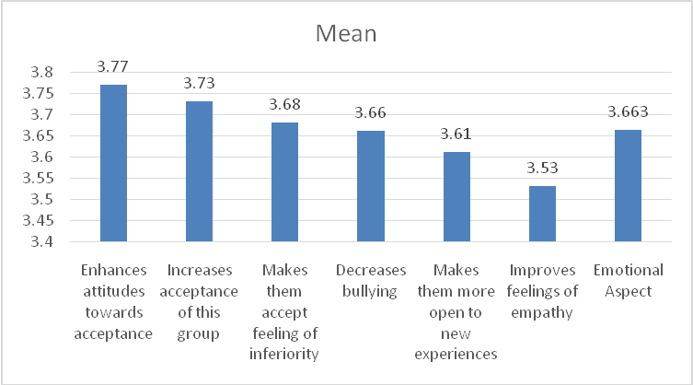

Table 5:Descriptive Statistics of Emotional Aspect Items
No | Statement | Mean | Std. Deviation | Rank | Level
2 | Enhances attitudes towards acceptance | 3.77 | 0.618 | 1 | High
1 | Increases acceptance of this group | 3.73 | 0.691 | 2 | High
5 | Makes them accept feeling of inferiority | 3.68 | 0.678 | 3 | High
4 | Decreases bullying | 3.66 | 0.718 | 4 | High
6 | Makes them more open to new experiences | 3.61 | 0.693 | 5 | High
3 | Improves feelings of empathy | 3.53 | 0.709 | 6 | High
 | Emotional Aspect | 3.663 | 0.549 |  | High

The results in the previous table showed that among the emotional aspect items, "Enhances attitudes towards acceptance" ranked first with a mean (3.77) and a standard deviation (0.618), followed by "Increases acceptance of this group" with a mean (3.73) and a standard deviation (0.691), and "Makes them accept feeling of inferiority" ranked third with a mean (3.68) and a standard deviation (0.678). "Decreases bullying" came fourth with a mean (3.66) and a standard deviation (0.718), "Makes them more open to new experiences" ranked fifth with a mean (3.61) and a standard deviation (0.693), and "Improves feelings of empathy" was sixth with a mean (3.53) and a standard deviation (0.709). Overall, the Emotional Aspect had a mean (3.663) with a standard deviation (0.549) and was at a high level, as shown in the following figure:
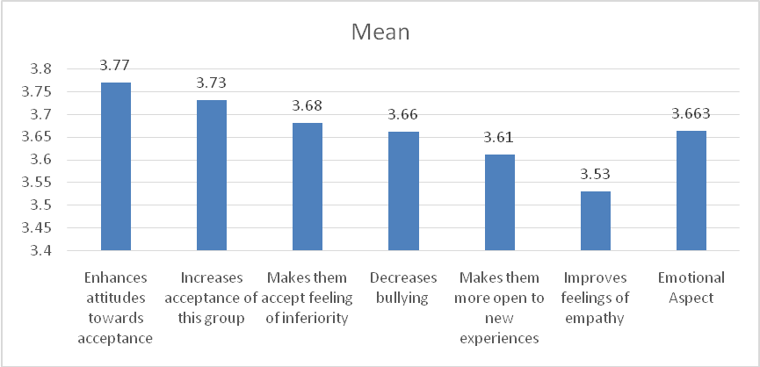
To answer the first research question, Pearson correlation coefficients were calculated between the main study variables, as shown in the following table:

Table 6:Pearson Correlation Coefficients among Social, Academic, and Emotional Aspects

Aspect | Pear corr. | Social Aspect | Academic Aspect | Emotional Aspect
Social Aspect | Pearson Correlation | 1 | .844(**) | .845(**)
 | Sig. (2-tailed) |  | .000 | .000
 | N | 365 | 365 | 365
Academic Aspect | Pearson Correlation | .844(**) | 1 | .849(**)
 | Sig. (2-tailed) | .000 |  | .000
 | N | 365 | 365 | 365
Emotional Aspect | Pearson Correlation | .845(**) | .849(**) | 1
 | Sig. (2-tailed) | .000 | .000
 | N | 365 | 365 | 365
** Correlation is significant at the 0.01 level (2-tailed).

The results in the previous table showed that the Social Aspect was positively correlated with the Academic Aspect (r = 0.844, p < 0.01) and with the Emotional Aspect (r = 0.845, p < 0.01). Additionally, the Academic Aspect was positively correlated with the Emotional Aspect (r = 0.849, p < 0.01). These correlations are statistically significant at the 0.01 level, indicating strong positive relationships among all three aspects.
After confirming the existence of strong correlations between the study variables, multiple regression analysis was conducted to examine the predictive relationships among the main variables and to determine the extent to which the Social and Academic Aspects predict the Emotional Aspect, as follows
Table 7:Multiple Regression Analysis Predicting Emotional Aspect from Social and Academic Aspects
Model |  | Standardized Coefficients |  | Beta | T | Sig | R | ²R
 |  | B | Std. Error
 | Constant | 0.519 | 0.093 |  | 5.592 | 0.000 | 0.882 | 0.778
 | Social Aspect | 0.452 | 0.047 | 0.446 | 9.657 | 0.000 | 0.882 | 0.778
 | Academic Aspect | 0.419 | 0.041 | 0.473 | 10.246 | 0.000 | 0.882 | 0.778
F= 635.253 sig.=0.00

The results of the multiple regression analysis showed that both the Social and Academic Aspects significantly predicted the Emotional Aspect. The Social Aspect had a standardized Beta coefficient of 0.446 (t = 9.657, p = 0.000), and the Academic Aspect had a standardized Beta coefficient of 0.473 (t = 10.246, p = 0.000), indicating that both variables contributed positively to predicting emotional outcomes. The regression model was statistically significant (F = 635.253, p = 0.000) with a high correlation coefficient (R = 0.882) and a determination coefficient (R² = 0.778), suggesting that approximately 77.8% of the variance in the Emotional Aspect is explained by the Social and Academic Aspects, as shown in the following figure

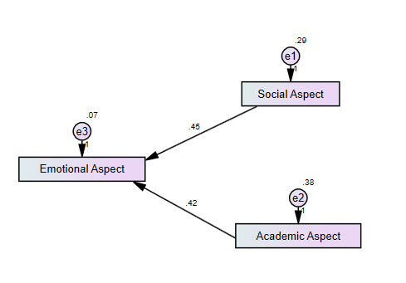
Are there statistically significant differences due to gender in the impact of inclusion on the Social, Academic and Emotional Aspects of students without special educational needs?
answer the second research question, which aimed to examine whether there are statistically significant differences due to gender in the impact of learning disability students’ integration in public schools on students without special educational needs’ social, academic, and emotional aspects, group statistics and independent samples t-tests were conducted. The results for male and female students are presented in Table 7, showing the means, standard deviations, t-values, and significance levels for each aspect

Table 8:Group Statistics for Gender Differences in Social, Academic, and Emotional Aspects and independent test due to gender (male, female)
Aspect | Gender | N | Mean | Std. Deviation | t | Sig. (2-tailed)
Social Aspect | Male | 140 | 3.607 | 0.345 | -1.521 | 0.129
 | Female | 225 | 3.696 | 0.632
Academic Aspect | Male | 140 | 3.531 | 0.377 | -0.480 | 0.631
 | Female | 225 | 3.563 | 0.730
Emotional Aspect | Male | 140 | 3.629 | 0.348 | -0.946 | 0.345
 | Female | 225 | 3.684 | 0.643

To answer the second research question regarding gender differences, the results showed that there were no statistically significant differences between male and female students in the impact of learning disability students’ integration on the Social, Academic, and Emotional Aspects. The Social Aspect had means of 3.607 for males and 3.696 for females (t = -1.521, p = 0.129), the Academic Aspect had means of 3.531 for males and 3.563 for females (t = -0.480, p = 0.631), and the Emotional Aspect had means of 3.629 for males and 3.684 for females (t = -0.946, p = 0.345). These results indicate that the impact of inclusion is consistent across both genders.
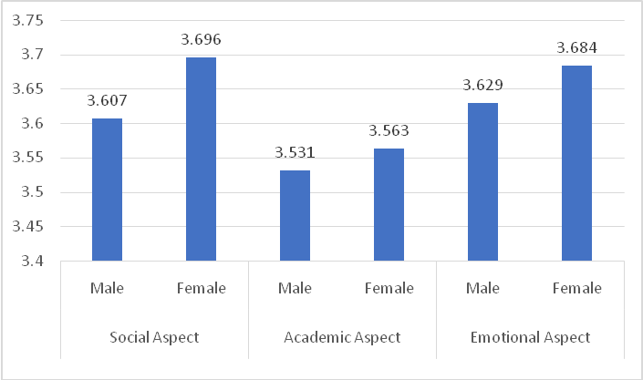

Discussion
The results of the study indicated that the inclusion of SENstudents with their peers without SEN had positive impact of the social, academic and emotional domains. Beginning with the social domain, this result may be due to the fact that the inclusion of SEN students with their peers without SEN, although being challenging for both groups of students, can be considered as a rich, informing opportunity for development. In this sense, these two group of students can interact with each other on daily basis. This provides a safe environment for communication and sharing ideas. This means that SENstudents with their peers without SENcan express their ideas without being intimidated by the judgements of others. By default, this has positive impact on these students' social skills as they are more willing to be active participants in the social interactions happening in the inclusive classroom.
Furthermore,the inclusion of SEN students with their peers without SEN may be a buffer against the negative attitudes students without special educational needs have when they find themselves in an inclusive classroom. As known, attitudes towards SEN students play a vital role in creating a positive class environment where every student can feel accepted and respected. In turn, this develops the magnitude of social interactions between SEN students with their peers without SEN. This has been proofed in the results of this study. Emphasizing this, Aldosari (2022) have stresses that attitudes of both students and teachers steer the direction of social interaction in the inclusive classroom. The researcher called for more positive attitudes by teachers and average students towards students with special educational needs in inclusive classrooms.
This result is consistent with the results reported byKart and Kart (2021) indicating that the inclusion of SENstudents with their peerswithout SENand working on altering teachers and students' attitudes in the inclusive school is very significant for the development of both groups. Specifically, students without SEN can engage in natural interaction with SEN students without the need to refer to their previous judgements that SEN students lack the needed social skills able to help then provide their valuable insights about the different ideas emerging in the social context.
As for the emotional domain, interaction between SEN students and their peers with SEN can nurture the positive emotional states that may arise during the interaction between these two groups of students. For example, it was proven in this study that both students can hold their temper, be better in controlling their negative emotions and these skills learned in the inclusive classroom can be employed in future social interactions needing to show high levels of emotional intelligence. In other words, being able to participate in interactions needing several emotional abilities can be an integral part of students without SEN and part of their personality. As known, students in this age group are still searching for their identity as they are in the middle of their identity formation and they maintain them for future endeavors. As indicated in psychological literature, the formation of identify begins from late childhood to late adolescence. This implies that students without SEN face challenging situations when being in the inclusive classroom as they spend their school day with their SEN peers and this needs various emotional skills. In their study, Kart and Kart (2021) recommended the need for interaction between SEN students and their peers without SEN as they found in their study that students without SEN can benefit from the invaluable opportunities to interact with students different from them.
As for the academic domain, which was last with respect to the positive impact of SEN students' inclusion on the various factors of students without Sen, it can be argued that the inclusion of former may hinder the academic development of students without SEN since inclusive teachers should make individualized plans for SEN students and this can hinder the pace of educational process for students without SEN. This, in turn, makes it difficult for inclusive teachers to dedicate the needed time for students without SEN.
As for the second question of the study, there were no statistically significant differences due to gender in the impact of inclusion of SEN students on the social, emotional and academic domains of students without SEN. This result is logical since students from both gender do not differ at the personal and academic levels. As this study is conducted in a state where co- educational learning is the mainstream practice, this indicates that share the same experiences and are from the same age group.
Recommendations
Based on the results, the following recommendations can be suggested:
- Teachers in inclusive schools can work on dedicating more effort on the academic domains of students without SEN.
- Regular survey studies targeting students without SEN should be a common practice in inclusive schools to identify their perceptions about inclusion as an educational practice.
- Future research should focus more on other variables not included in this study such as psychological ones.
References
- Aldosari, M. (2022). Factors affecting middle school teachers’ attitudes toward inclusion of students with disabilities. Frontiers in Psychology,13, 1-8.
- Almalky, H., &Alwahbi,A. (2023). Teachers’ perceptions of their experience with inclusive education practices in Saudi Arabia. Research In Developmental Disabilities, 140, 1-12.
- Avramidis, E., Toulia, A., Tsihouridis, C., &Strogilos, V. (2019). Teachers' attitudes towards inclusion and their self-efficacy for inclusive practices as predictors of willingness to implement peer tutoring. Journal of Research in Special Educational Needs, 19(3), 152-165.
- Bashir, T., Fatima, N., Abbas, S., & Bano, B. (2026). Evaluating the effectiveness of inclusion models for students with learning disabilities. Social Science Review Archives, 4(1), 501-512.
- Buchner T, &Proyer M. (2020). From special to inclusive education policies in Austria–developments and implications for schools and teacher education. European Journal of Teachers Education. 43, 83–94.
- Chen, S., Huang, Q., Liu, Z., & Wang, H. (2022). Inclusion of young children with special needs in early childhood education in the United States: Advantages and disadvantages. International Conference on Social Development and Media Communication,631, 195-202.
- Desombre, C., Delaval, M., & Jury, M. (2021). Influence of social support on teachers’ attitudes toward inclusive education. Front. Psychol., 12, 1-7.
- García, P. S., & Resino, D. A. (2022). Teaching attitudes toward students with disabilities. Espíral Cuadernos del Profesorado, 15(30), 83-83.
- Hascher, T., &Hagenauer, G. (2020). Swiss adolescents’ well-being in school. Swiss J. Educ. Res.,42, 367–390.
- Huang1, H., Zhang, Y., Huang, Y., Sun, Y., & Wang, C. (2025).The role of inclusive education in the learning and social–emotional skills of students without special educational needs. European Journal of Education, 60(2), 1-13.
- Junaidi, A. R. (2019). Teachers’ attitudes toward inclusive education in East Java. Journal of ICSAR, 4(1), 1-4.
- Kart, A., &Kart, M. (2021). Academic and social effects of inclusion on students without disabilities: A review of the literature.Educ. Sci., 11 (16), 1-13.
- Leblebici, H., & Türkan, A. (2021). Opinions of teacher candidates on inclusive education: A parallelmixed method study. International Journal of Education and Literacy Studies, 9(4), 32–44.
- Liu, X., & Potmesil, M. (2025). A review of research on the development of inclusive education in children with special educational needs over the past 10 years: A visual analysis based on Cite Space. InFrontiers in Education, 9: 1-13.
- Nam, N., &Tan, H. (2024). Inclusive education: Enhancing social integration and academic achievement for students with and without learning disabilities aged 5 to 14. Journal of Science: Education Research, 41(1), 94-104.
- Obah, A.(2024). The effectiveness of inclusive education policies for students with disabilities. International Journal of Humanity and Social Sciences, 2(5), 50-63.
- Okoye, U.,&Maryqueen, O. (2025). Educational laws and their impact on inclusive education for students with disabilities in Anambra state: implications for sustainable development. Unizik Journal of Educational Laws and Leadership Studies,1, 144-155.
- Pirker, A., Hafenscher, J., & Lindner, K. (2023). Investigating the self-perception of social, emotional, and academic inclusion of students with and without special educational needs through photovoice. Educ. Sci., 13 (423), 1-18.
- Supriyanto, D. (2019). Teachers’ attitudes toward inclusive education: A literature review. Indonesian Journal of Disability Studies, 6(1), 29-37.
- Szumski, G., Smogorzewska, J., &Grygiel, P. (2022) Academic achievement of students without special educational needs and disabilities in inclusive education: Does the type of inclusion matter? PLoS ONE, 17(7), 1-19.
- Wahsheh, N. (2024). The inclusion of students with disabilities: Teachers’ attitudes. Multidisciplinary Science Journal, 6(12), 1-9.
- Yusuf, F., &Fajari, L. (2025). Empowering inclusive education: Management practices in pilot elementary schools for inclusion. Educational Process: International Journal,15, 1-22.

